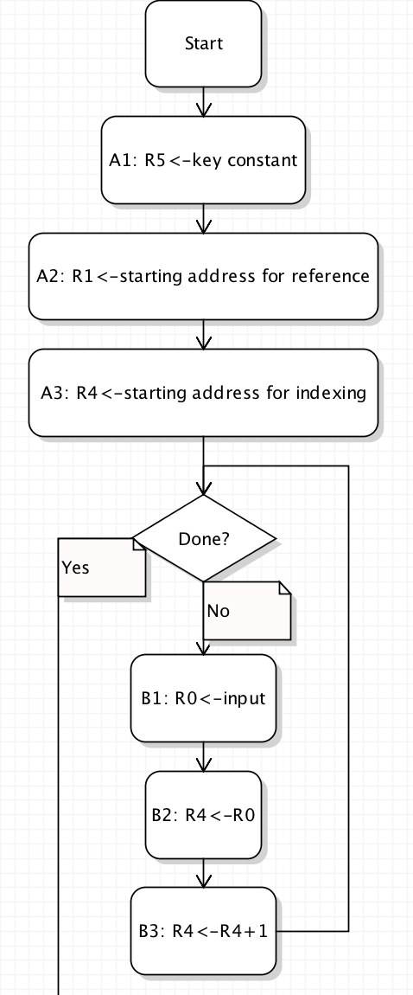

.ORIG x3000

LD R5, #31// key constant (ex.: #-1)

LD R1, #32 // starting address

LD R4, #32 // starting address

***AND R3, R3, #0***

***AND R5, R5, #0***

***AND R6,R6,#0***

***//THIS FONT MEANS NEEDS TO BE ADDED TO CHART***

TRAP x23

ADD R6, R0, #-13

BR z #4

ADD R4, R0, #0

ADD R4, R4, #1

***ADD R3, R3, #1***

BR nzp #-6

//EDIT!!!: B2: M[R4]<-R0

ADD R4, R1, #0

LDR R2, R4, #0

***ADD R5, R3, #0***

ADD R3, R3, #-1

BR n #4

ADD R2, R2, R5

STR R4, R2, #0

ADD R4, R4, #1

LDR R2, R4, #0

BR nzp #-7

ADD R0, R1, #0

//TO DO!!!: D1 and D2

ADD R5, R5, #-1

BR n #4

LDR R0, R1, #0

TRAP x21

ADD R1, R1, #1

BR nzp #-6

TRAP x25

END

xFFFF

.BLKW 20

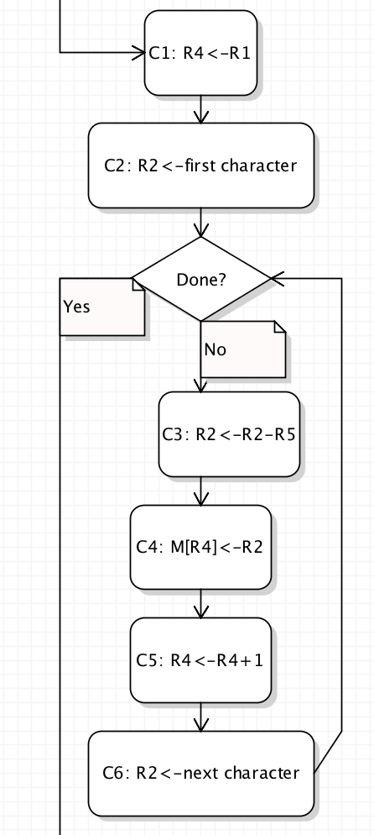

C

